Patient information
Cervical cell changes
(Cervical dysplasia); tissue sampling

A cell sample (cytology), or HPV (human papilloma virus) test from your cervix has revealed changes that need closer examination. To find out if you need treatment, or just further check-ups, we need to take a tissue sample (biopsy).

These cell changes are caused by a virus infection (HPV). As with other virus infections, the body normally rids itself of the virus eventually, however, sometimes this does not happen, and the changes become precancerous. In rare cases, cancer develops.

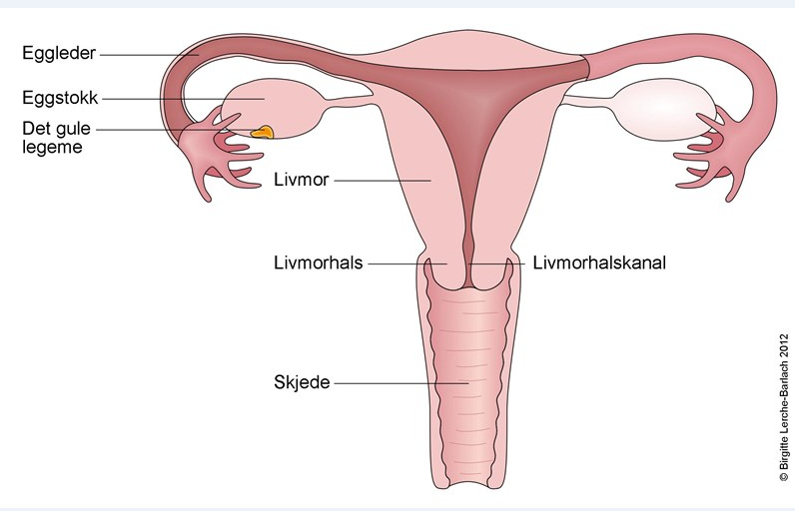
Illustrasjon er hentet fra Norsk elektronisk legehåndbok (NEL)

Tissue sampling (biopsy)
We carry out a gynaecological examination where we also use a microscope to detect changes on the cervix. Tissue samples are taken from these areas, both in the form of small sections of the surface of the cervix, and scrapings from the cervical canal. This is done under local anaesthetic.
The samples are sent for analysis (histology).

Follow-up
1) If the sample is normal, or only shows slight changes that do not require treatment, we will plan a follow-up cell sample after a few months - usually at your GP's/family doctor's office.

2) If the sample confirms the presence of serious cell changes, treatment is recommended. The outermost part of the cervix, where the cell changes are situated, is removed. This is an outpatient procedure using the same type of local anaesthetic as for the tissue sample. If this is the case, you will receive a letter and a separate information sheet.
It will normally take 4-8 weeks from the examination until the results are ready. The results are sent to the referring doctor. You will be contacted if this has been agreed upon.

After the sample
Up to several days of bleeding is normal after the tissue sample.
Intercourse, bathing, and use of tampons should be avoided as long as there is bleeding. If you bleed heavily you can contact the hospital.
A sick note is not necessary.

Telephone:
Main Number 51 51 87 77
Welcome to the Women's Clinic
Stavanger University Hospital

hh

[Siter kilden din her.]
Kvinneklinikken SUS, januar 2019
www.sus.no/kvinneklinkken

